Skin Graph-t

5/30/15

Technical Writer: Everyone

Engineer: Everyone

Reporter: Everyone

Conductor: Everyone

Very nice work! Your proof-writing has improved tremendously. Be careful about the definition of bipartite graphs, and try drawing more examples and diagrams to guide your explorations.

--RK

Morning Session: This Morning Dr. Doug asked us to four graphs. Find a graph where

𝑋≄ɷ

θ≄ɑ

𝑋=ɷ and θ≄ɑ

𝑋≄ɷ and θ=ɑ

Dr. Doug also explained to us what perfect graphs were and gave us several new vocabulary terms to add to our notebook/folders. Induced subgraphs are subgraphs that require every edge that corresponds to the vertices to be shown. A graph is perfect when all of the induced subgraphs of said graph must fit 𝑋= ɷ and θ=ɑ. Doug also showed us a new game called cops and robbers where two players would use a graph as a battleground. The cop would move along the edges of the graph to chase the robber and eventually subdue him/her. There could be more than one cop and only one robber. The cop would win if he could catch the robber, however if the graph allowed the robber to run around indefinitely then the robber would claim victory. Nice report!--RK

Afternoon Session: In the afternoon the homework was fairly straightforward and it was quite easy to apply what was learned this morning to the worksheet we were given. There were no issues on the problems that we solved. Other than that this afternoon was fairly mundane.

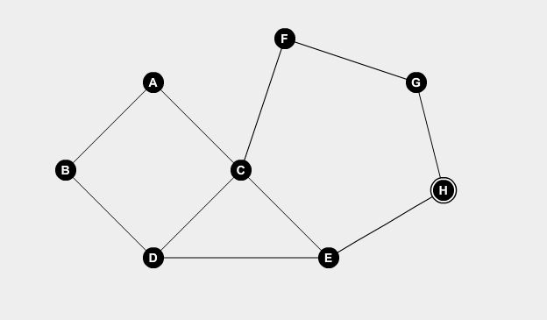

1. This graph has a chromatic number of 3 and a clique number of 3. It also has a clique partition number of 4 and an independence number of 4. However this graph is not perfect because it contains a 5 cycle which has a chromatic number of 3 and a clique number of 2.

* The clique number on this graph is 3 (C,D,E)... At least, I think its this graph I have a feelin youre taking about 2 graphs? This is confusing, But I agree that the graph that you have to the left does meet the requirements of the question. - Lizzy

No problem 2?--RK

3a) In the graph, vertex A can have 5 colors. Vertices D,B,C can have 4 colors as they cannot be the same color as A. The number of ways to color K1,3 with up to five colors is equal to 5*4^3=320

Great!--RK

3b) If a graph, G, has n vertices and zero edges, and k possible colors, it must have a chromatic polynomial, Pk(G), kn. This is because none of the vertices are connected, and thus none are forced to any particular color. Therefore, there would be n vertices, each with k possible colors, prompting the number of possible color combos, or Pk(G) to be equal to kn. ***Q.E.D.***

Very nice explanation!--RK

3c) Consider a graph, G, that is acyclical (Actually the word is “acyclic.”--RK) and connected. Assume this graph has k possible edges and order n. Since it is acyclical and connected, there will be a vertex, v1, where all k colors are usable. V1’s neighbors will all have (k-1) color possibilities, as they can have any of the k colors, EXCEPT whatever color is used in v1. Since you will give v1 k color possibilities, its neighbors in this acyclical, connected graph will be forced to have k-1 color possibilities since they can’t be the same color as v1. Since the graph is acyclical, there would be no need for the non v1 vertices to have a value less than (k-1). Thus, the formula to find the chromatic polynomial of G is k(k-1)n-1. The k value is representing v1 and its k color possibilities in G. (k-1) represents the values of non v1 vertices in G. n-1 represents the number of non v-1 vertices in G. ***Q.E.D***

This is definitely convincing! I would emphasize that you’re coloring in the vertices step-by-step, not just coloring v1 and then coloring in the others all at once. For example, you might say “We have k-1 options for each of v1’s neighbors, since they cannot be the same color as v1’. Let w be a neighbor of v1. By the same argument, we have k-1 options for each neighbor of w other than v1, and so on. Since the graph is acyclic, we eventually reach every vertex in this way.”--RK

4. a) Graph G will include a subgraph with vertices x and y. Since x and y are adjacent with the edge e between them, they cannot be the same color. Thus the possible number of colors of x and y would be equal to (k)(k-1).

The graph G-e will include a subgraph with vertices x and y that are not neighbors. Given that x and y are different colors, the possible number of colors of x and y would be equal to (k)(k-1). As this value is equivalent to that of Graph G, the number of colorings is the same for both graphs.

This argument does not work--can you see why? Since x and y are not neighbors, they could be the same color in G-e. How many colorings does that give you?

b) In graph G, it is given that x and y are the same color. As a result, all neighbors of x and y have k-1 possible colors as they cannot be the same color as x and y.

In graph G*e, the vertex m is neighbors with all of x’s and y’s former neighbors. As m has k colorings, its neighbors have k-1 colorings. This number is equal.

I’m not convinced by this argument either. It looks like you don’t quite have a handle on the set-up of this problem. Drawing some examples or schematic diagrams might help.--RK

5.



* Good :] - Lizzy

6. 3 - Please include an explanation next time, also, what is the proof that it cant be done with 2, or that it must use 4? - Lizzy

7. Having a corner is not a necessary condition for a cop-win graph. The following graph has a vertex u but no equivalent v.

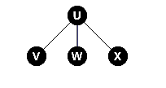

Having a corner is not a sufficient condition for a cop-win graph - the graph has a corner u with every vertex adjacent to u being adjacent to v, however the graph is not a cop-win graph.

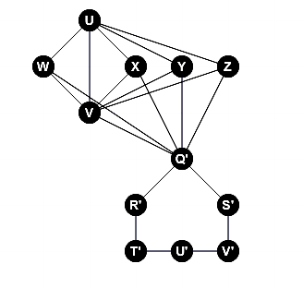 

* Good job, and good examples, I like the explanation you provided. - Lizzy

8. In a bipartite graph, we have two independent sets. Since in the complement of a graph, all vertices that are independent become connected, the complement of a bipartite graph would contain two complete sets. In a complete set, the order of the set is equal to the chromatic number, because every vertex would be connected to every other vertex by definition and thus every vertex would require a different color since vertices that are adjacent to each other cannot have the same color. In addition, every subgraph of a complete graph would be complete as well, because every vertex would still be connected. Therefore, with every vertex having a different color in the largest complete subgraph, the chromatic number would be equal to the clique number.

Your solution works for the *complete* bipartite graph; that is, the graph where every vertex in set A is connected to every vertex in set B. Your explanation for why Kn is perfect is excellent! However, in general, a bipartite graph may not have edges between every vertex in set A and every vertex in set B, so the complement may not be a union of complete graphs. Can you prove the same result in that case?--RK

